Hi Robert,
I hope this is helps you to think about how I might contribute to your work at Wonder. Please don’t hesitate to reach out, if there is anything else you’d like to know!
Big Bins: Research, Communications, Advocacy and Strategy
Past projects have focused on: Sexual and Reproductive Health, Women & Girls Rights, Gender Based Violence, HIV/AIDS awareness and prevention, masculinity and gender, social practice art
Sweet spots: Qualitative research design and analysis, integration of multimedia in qualitative design, multimedia/content production, and participatory media training/production.
I’ve worked on projects that employ community based participatory research approaches and most significant change methodology as ways of bringing participants into the collection and analysis processes. I’m interested in experimenting with these participatory approaches to research (and storytelling) to create messaging and impact stories/narratives.

Example 1

Client: Global Fund for Women is one of the world’s leading foundations for gender equality, standing up for the human rights of women and girls.
Challenge: Create a 9-month online multimedia campaign and advocacy project around women and technology. The project must be a transitional campaign demonstrating the increased post-merger power of Global Fund for Women (merger with International Museum of Women in 2014), and hint at the organization’s new strategy and direction. The campaign should explicitly highlight Global Fund for Women grantees (few of whom were actually working with science and technology) and position Global Fund for Women as an influencer and thought leader on issues of technology and gender equality.
Project Target Audience: Women and Girls ages 18-35
Hackathon Participants: Girls and Young Women ages 12-21
Role: Producer of IGNITE: Women Fueling Science and Technology. Led the design and production of IGNITE: Women Fueling Science and Technology, a nine-month multimedia storytelling project and global advocacy campaign that explored the roles of science and technology on advancing women's human rights. For this project I created a campaign strategy and content plan, and then produced or oversaw the production of:
- Five thematic galleries.
  - Visionaries
  - Creatives
  - Leaders
  - Geeks
  - Changemakers
Each gallery contained 10-12 unique multimedia stories (including commissioned artists and crowd sourced stories) and championed by a globally prominent female thought leader. These included, Facebook COO and Lean In: Women, Work, and the Will to Lead author Sheryl Sandberg; Executive Director of Girls Who Code, Reshma Saujani; singer/songwriter, Carolyn Malachi; Director-General of UNESCO, Irina Bokova; and Founder and Executive Director of Black Girls CODE, Kimberly Bryant.
- Online petition. Collected +23,000 online signatories for petition demanding equal access to and control of technology for women and girls. The petition was presented to UN officials including UN Women’s Executive Director and the Under Secretary of UNESCO.
- Spark Stories. Designed platform and prompt that enabled visitors to the IGNITE website to upload and share their own stories
- International Girls Hackathon. Designed, produced and coordinated Global Fund for Women's first innovation challenge — a five city (Taipei, Taiwan; Porto Alegre, Brazil; Oakland, USA; New York, USA; Trivandrum, India) international girls hackathon focused on women and girls’ access to safe spaces.
- Discussion Toolkit; Created a discussion guide to facilitate in-depth discussion of the site content
Impact: When we evaluated the project impact we mostly looked at engagement and reach. The evaluation questions explored the extent to which IGNITE effectively: a) engaged and reached its target audiences, b) achieved its expected outcomes, c) enhanced the visibility and urgency of the gender gap in technology access and control and d) positioned Global Fund for Women as a thought leader to promote gender equality in science and technology. Surveys were also conducted with our audiences and partners to measure the quality, innovation, and impact of the project.
Some of the project’s achievements follow:
- Five thematic galleries showcasing 65 multimedia stories
  - Visionaries
  - Creatives
  - Leaders
  - Geeks
  - Changemakers
- Social Media: the IGNITE project hashtag, #bethespark, has reached over 200 million social media users since the project launch in November 2014, #hackgirlsrights, the Hackathon hashtag, reached over 50.8 million social media users.
- Page Views: 120k page views
- Petition: +23k signatories from 182 countries delivered to UN officials at Commission on Status of Women 2015
- Media Engagements: 21 media placements including Mother Jones, Devex, Women Enews, ThinkProgress, Chicago Tribune, Mic
- Presentations: UNESCO Mobile Learning Week 2015, International Human Rights Funders Group 2016, Women Deliver 2016
- New Social Media Followers (Global Fund for Women): +85k
- Partners: 22 new partnerships
Content Samples: Infographic (researched and scripted), Essay from CEO (wrote), Launch Video, (wrote and edited, created prompt for grantees to respond for video) Hackathon Video, (made in collaboration with filmmakers in five global cities)

Example 2

Client: Memphis Music Initiative is a three- year pilot project investing in Memphis, its youth, its communities and its musical legacy by broadening and strengthening existing music engagement offerings in and out of schools and supporting youth-centered, community-based music spaces. The pilot project grew out of a participatory strategic planning process that involved youth, parents, city leadership, arts leadership and musicians.

Challenge (1): Design a youth-led strategic planning component that engages young people, parents and youth leadership organizations that enables young people to contribute to a viable plan for universal music education in the city of Memphis.
My role (1): Strategist, Trainer, Designer. Designed and implemented photo-based asset mapping project with Memphis youth leaders.

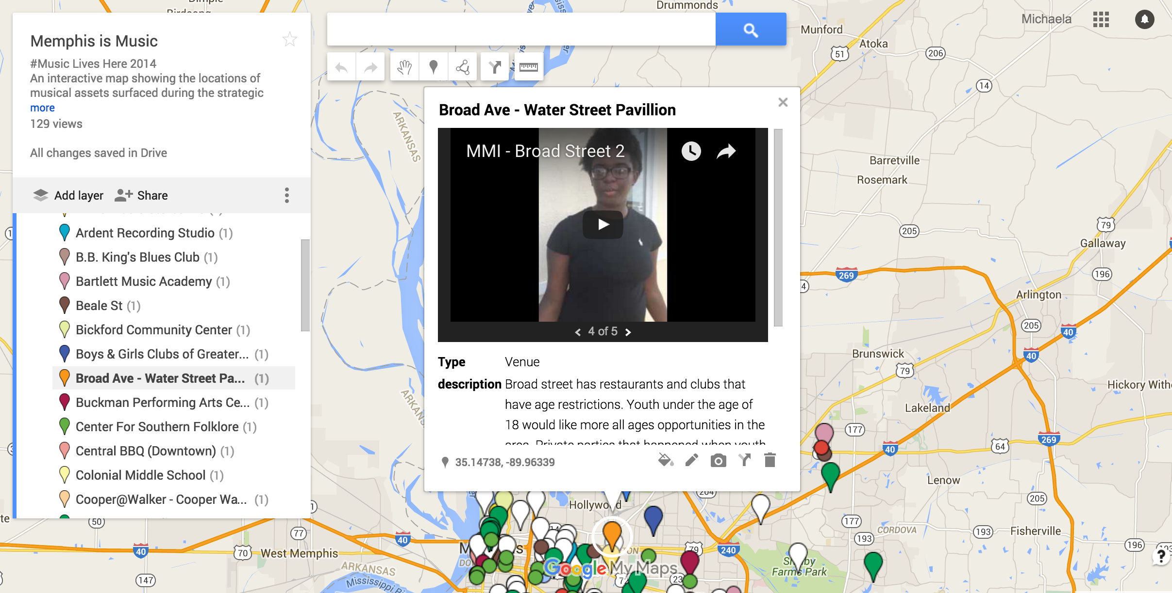

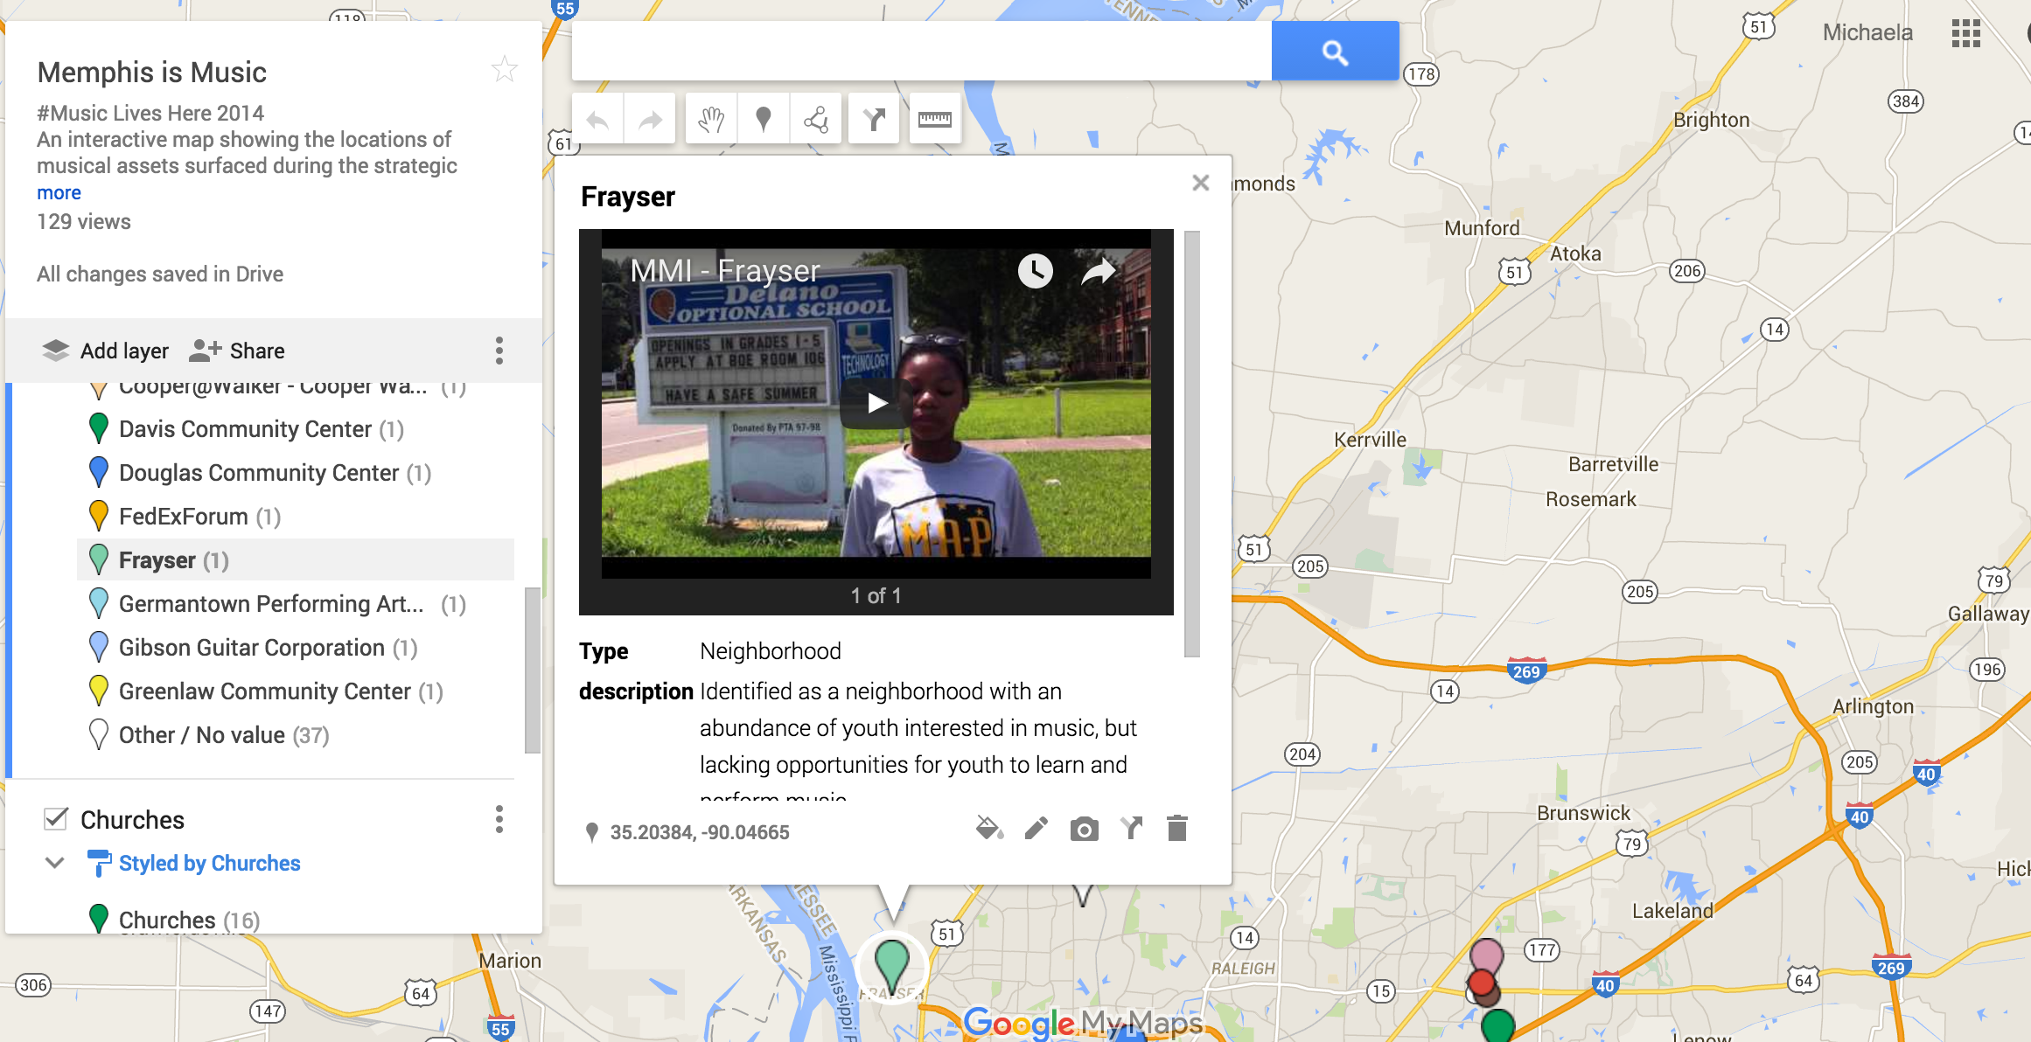
Worked with three youth leadership organizations in Memphis to select 20 young people interested in research, community building and the arts. I trained youth leaders in basic photography, videography and interviewing and together we created criteria for evaluating city arts institutions’ success at reaching and serving young people. Youth looked at issues of access, appropriateness of programming or content, visibility among peers, use of social media etc. The youth embedded these images and interviews on a customized Google Map of Memphis and created a set of recommendations for the strategic plan that included design and development of youth music hubs throughout the city.
Challenge (2): Document the broader community-led planning process and create a vehicle to communicate the process to strategy stakeholders (the City of Memphis).

Role (2): Filmmaker. I worked with a local filmmaker in Memphis to create a short video documenting the strategic planning process and capturing key stakeholders thoughts about the potential of the project.

Content sample: https://vimeo.com/105578191#at=1
Impact: The resulting strategic plan was approved by the funder and became the foundation of a three-year pilot project ($20 million grant), now called Memphis Music Initiative.
Challenge (3): Later when the pilot launched I was asked to create a tagline and a series of short videos that showed the excitement of participants in the Initiative (musicians, teachers and students) and signaled the potential for long-term impact.
Role (3): Filmmaker, Strategist. I wrote and produced three short videos for MMI’s launch. Videos were co-produced with a Memphis-based collaborator I worked with to document the strategy process the year before.
Content Sample: Leaders, Musicians and Youth
Impact: Ongoing
Example 3
Client: ITVS Women & Girls Lead Global trains partner organizations to use film to initiate breakthrough conversations with communities on the ground — and those conversations about issues like teen pregnancy and early marriage, become a springboard for action.
Challenge: Develop a mechanism for gathering new ideas to meet current programmatic challenges identified by Women & Girls Lead Global program.
Role: Challenge designer, event coordinator and facilitator. I designed a one-day collaborative challenge that engaged technologists, members of US State Department, in-country coordinators of Women & Girls Lead Global and communications and M&E professionals. Together with a graphic artist/visual co-facilitator we adapted a design thinking process to brainstorm, prioritize and design five new technology-based ‘solutions’ to meet current challenges in the Women and Girls Lead program. Solutions ranged from new ways of collecting and analyzing information, to apps providing linkages between program participants and local government, men and boys- centered sexual and reproductive health programing and GIS-enabled technology.
Impact: ITVS is working to synthesize the solutions and determine partnerships that will allow them to prototype the most viable.
Content Samples:
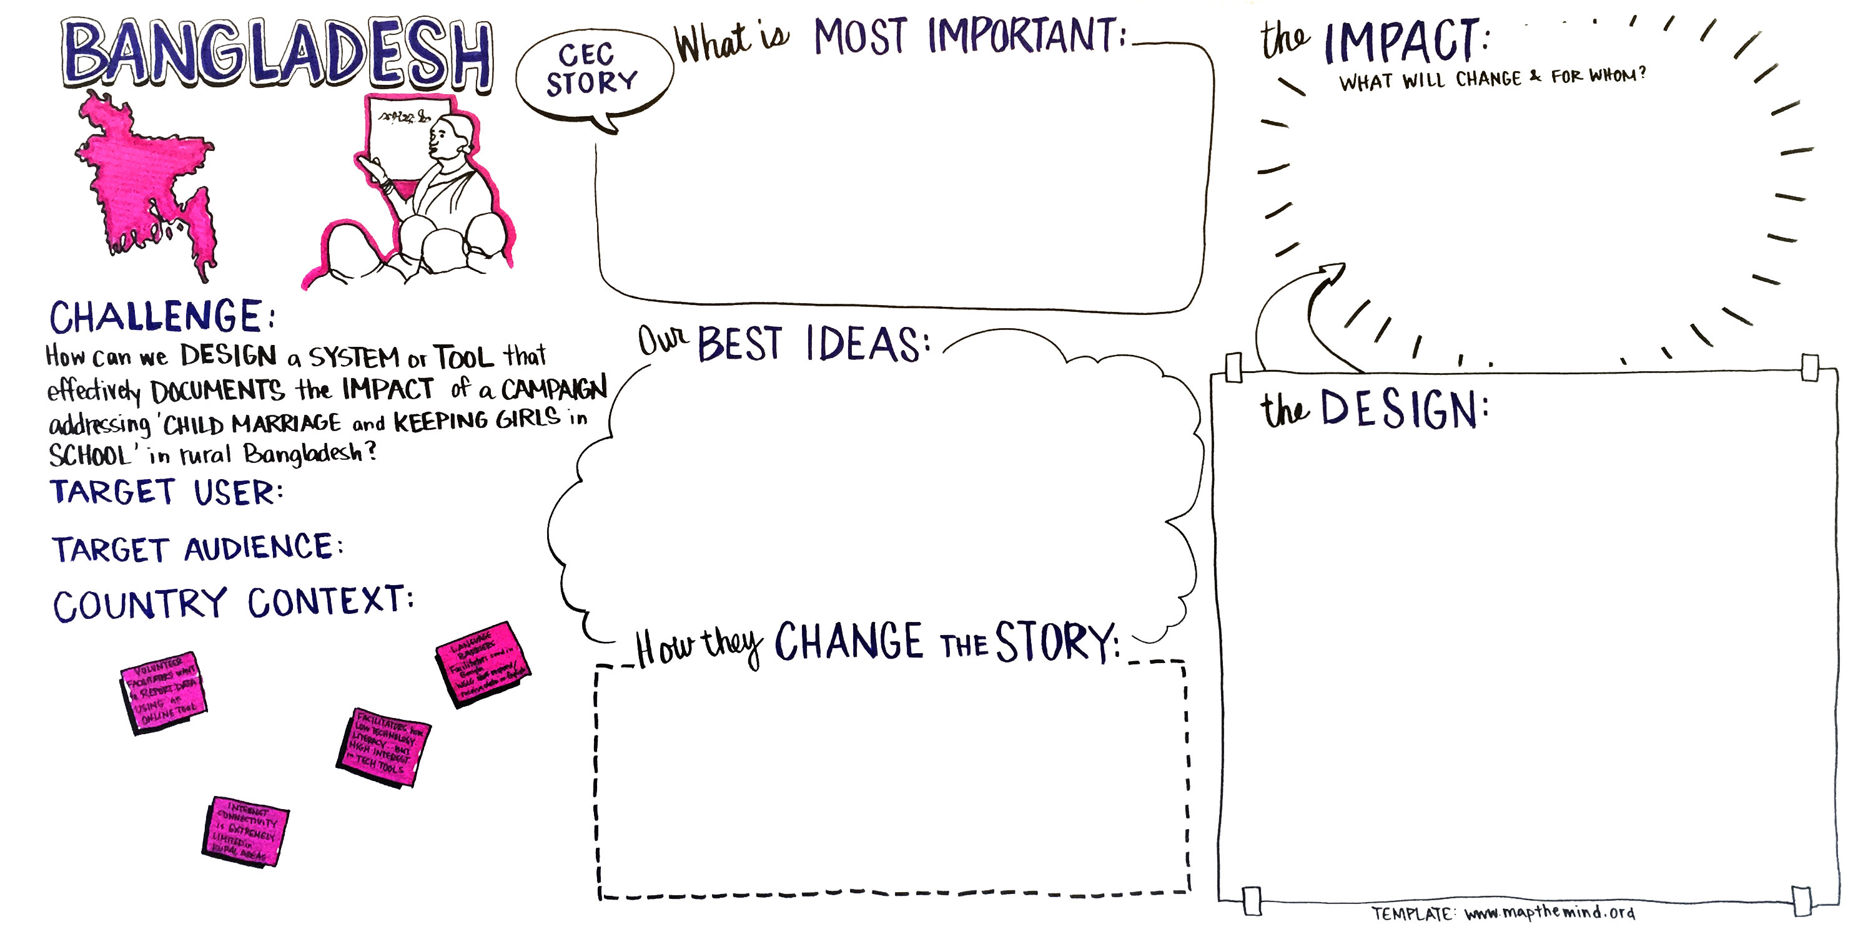
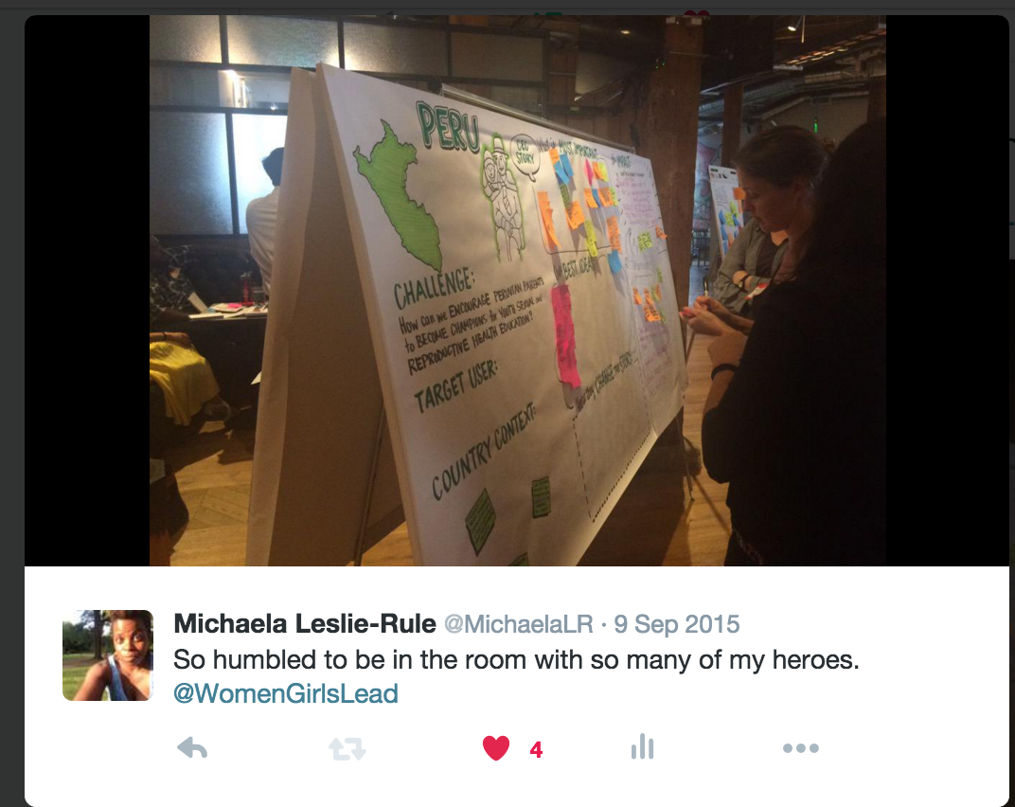

Client: Nike Foundation/Firelight Foundation
Example 4
Project: Grassroots Girls Initiative is a consortium of six funders that believe grassroots organizations are uniquely qualified to design and implement effective solutions for the most underserved girls in the communities where they work. The Nike Foundation launched the Grassroots Girls Initiative in 2006 as a part of its work to support the girl effect.
Challenge: Nike Foundation wanted to diversify the ways that grassroots organizations conducted monitoring and reporting for girl-centered programs. Specifically collecting girls’ stories about the impact of the Grassroots Girls Initiative.

Role: Designer, Trainer, Content co-producer (video and images produced in collaboration with grassroots organizations and with the girl participants). For GGI I developed a digital storytelling and media framework that could be integrated into the initiative’s existing M&E framework. The storytelling framework provided a methodology for story collection and story creation, and also introduced a selection of girls in Rwanda and Malawi to mobile media production (on IPhones and tablets).

Content Samples:
http://factmemorytestimony.com/project/nike-foundation-grassroots-girls-initiative/
http://www.firelightfoundation.org/impact/girls-empowered/

Example 5
Client: Community Foundation of Monterey County
Project: Girls’ Health in Girls’ Hands (GHGH) is an initiative of the Community Foundation of Monterey County’s Women's Fund that gives girls in Monterey County a voice in shaping their future.

Challenge: GHGH needed a longitudinal case study of the individual, programming and agency changes in relation to the GHGH Collaborative. This documentation will track selected girl participants and practitioner educators from each program and the partner agencies over a two (2) year period to assess collaborative impact. The deliverables needed to be varied with one internal report on the girls and one on the educators and then an external facing piece that included media.
My role: Researcher, Multimedia Producer. With my colleague Rebecca Aced-Molina designed an 18-month research project (time shifted in contract) that followed girls and staff from partner agencies. I focused on the girls and Rebecca worked with agency staff.
I produced a qualitative narrative and digital media project to complement the regular GHGH evaluation conducted by Monterey Public Health Department. Through the digital media and documentation project CFMC explored girl participants understanding and application of key concepts and principles related to GHGH outcomes and objective areas. Through first-person reflections on leadership, self-esteem, agency, health and sexuality, CFMC learned more about how girls apply their GHGH experience and identified critical areas for improvement. Over the course of the 2014-15 school year reflections were collected in two in-person interviews (the second of which was recorded on video) and several short video diaries recorded by the girls and submitted to FMT.

Impact: Videos and final report will be released in Spring 2016.

Content Sample: https://www.dropbox.com/home/business/clients/fmt_ghgh/Deliverables/VF%20-%2012112015?preview=GHGH_Landing+12112015.docx
Password for all videos is ‘GHGH’

Please keep these confidential.

Finally I’ve also done mission and vision statement work, Theories of Change and straight organizational strategy. Most of this work has been conducted with an embedded participatory approach to design, language and final visual presentation. Let me know if you’d like to see examples of reports or TOC.
I hope this helps,
Michaela

